2.10 | Senior Timeline Planning Worksheet

Student Name | Student Email
Major of Interest

Post-High School Plans

Write down what you want to do after high school? Please be as specific as you can (E.g. - college, work, etc.).

If you’re not sure, think about the lifestyle you are envisioning for yourself, we’ll work backwards!

College List
Please list down all schools you are interested in applying to
University of California:
California State University:
Privates/HBSU/Out-of-State:
Community College:

S.M.A.R.T. Goals
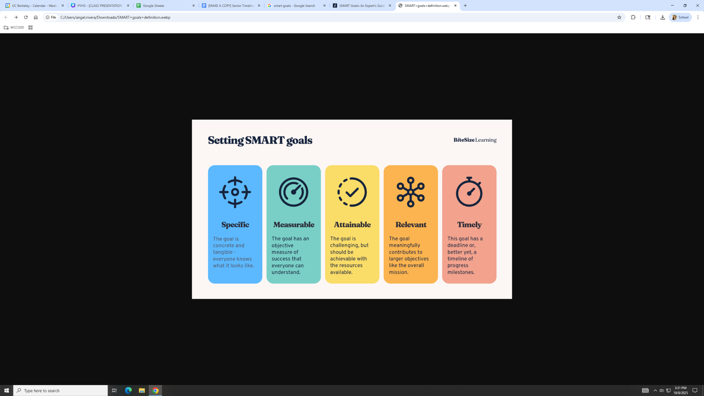
Hold yourself accountable. Write down 1 S.M.A.R.T. goal for this senior year.
**Remember: This is to make sure you are taking actionable steps towards your future**
🎯 SMART Goal Example: College Application Accountability Plan
Specific:
I will complete and submit my UC and CSU college applications by the November 30th deadline. This includes writing and revising my Personal Insight Questions, requesting recommendation letters where needed, and finalizing my activities and awards sections.
Measurable:
I’ll track my progress weekly by maintaining a checklist of completed application components (personal statements, transcripts, letters, forms, etc.) and marking each as done. I will also schedule two peer or teacher review sessions to get feedback on my essays before submission.
Attainable:
I’ve already drafted my Personal Insight Questions in English class, and I’ll dedicate one hour on Sundays to work on college apps. As long as I stay on top of the timeline I should be able to realistically meet each milestone before the final deadline.
Relevant:
Finishing these applications early ensures I’m eligible for a range of California universities that align with my academic and career goals in environmental science. It also reduces last-minute stress and gives me time to focus on scholarship opportunities.
Timely:
By November 1st, I’ll have my UC essays fully revised. By November 15th, all applications will be reviewed and ready for submission. Final submission will occur before the November 30th UC/CSU deadline.

Specific:
I will apply to the Contra Costa College Automotive Technology Program by March 15th and complete all required steps, including submitting my application, financial aid (FAFSA), and scheduling an appointment with an academic counselor to plan my first semester courses.
Measurable:
I’ll create a checklist to track each step — program application, FAFSA submission, transcript request, counselor meeting, and required placement tests. I’ll check off each milestone as I complete it and share progress with my college and career advisor.
Attainable:
I’ve already gathered most of my documents and can use the school’s College & Career Center to complete my FAFSA and application with staff support. With one afternoon per week set aside for this process, I can stay on track to finish by the deadline.
Relevant:
This goal directly supports my plan to start a skilled trade career after high school. The automotive program aligns with my interests and strengths in mechanics and hands-on problem solving, preparing me for ASE certification and long-term job stability.
Timely:
By February 15th, I’ll have completed my FAFSA. By March 1st, I’ll finalize my personal statement and gather required documents. My goal is to fully submit my application and meet with an academic counselor by March 15th.

⚙️ Your Smart Goal Goes here
Specific:
Measurable:
Attainable:
Relevant:
Timely:

